Introduction
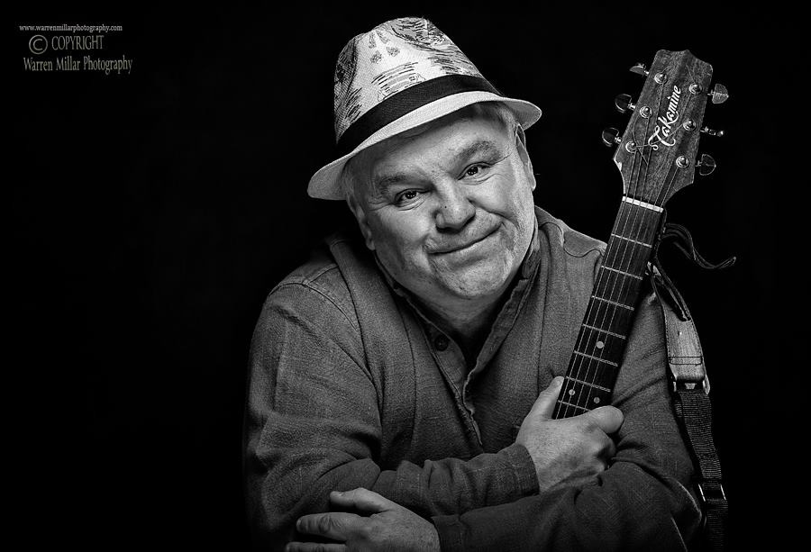
- I have worked professionally in and around music and arts projects, both private and public sector, since 1989

- I am up to date online with the DBS Update Service

- I have Team Teach certification until 2017

- Via my Musicians Union membership I have my own Public Liability Insurance

- I have musical performance and production equipment available as required

My preferred specialist areas of work are:

- Music and ICT (Functional Skills) Tutoring, Leadership, Therapeutic Support

- Project Management (Arts and Music)

- Live Music Performance, Production and Touring

- Event Planning, Programming and Promotion

- Web Design and Social Networking

Music and ICT (Functional Skills) Tutoring, Leadership, Therapeutic Support:

Special needs environments delivering accredited learning and non-accredited therapeutic activities have provided my most recent areas of work.

- I work in school educating and supporting EBD (Emotional and Behavioural Difficulties) pupils aged 11-16

- I have worked in school specialising in providing education and support for Autistic Spectrum pupils aged 8-16

- I have taught Higher Education Music at BTEC Level

- I provide music project leadership for West Cheshire Council in two of their ‘Buddies’ (SEN) youth clubs

- I was music leader for Bickerton Youth Music Group (non-formal, mainstream, young people aged 11-18)

- I have worked as an associate music leader with Drake Music and Manchester Camerata, delivering music projects for people with severe physical disabilities, and mixed ability school children

- I have delivered therapeutic support for Archangel Care Homes

- I deliver live performances for Arts For Health (South Staffordshire & Shropshire Healthcare NHS Trust).

Project Management

- I was commissioned as Project Manager for Music Leader (North East region), undertaking across a funded 18 month period to provide and manage non-formal training for musicians, and commission research projects highlighting areas where training and music projects can serve to aid education and social deprivation.

- I have through various projects worked as an associate partner with organisations such as Youth Music (UK), Middlesbrough Council, Brighter Sound and Manchester Camerata.

Live Music Performance, Production and Touring

- I have since 1986 performed around the UK (with some US touring) as an accomplished singer songwriter, performing at prestigious events and venues such as Glastonbury Festival, Edinburgh Festival, Belladrum Tartan Heart Festival, The Acoustic Festival Of Britain, and The International Guitar Festival of Great Britain

- I play both solo and with small groups of accompanying musicians, both professional and informally

- I have undertaken tour management and stage management, working with music artistes from UK and abroad

Live Entertainment Programming and Promotion

- For 10 years (1989 – 1999) I managed a live music venue, booking and promoting approximately 2,500 events

- I programmed entertainment and arranged sponsored advertising for two council run annual ‘fun day’ events

- I worked two years with an established Entertainments Agency, managing and promoting professional and semi-professional artists and entertainers.

Web Design and Social Networking

- During a break from formal employment I developed a small business enterprise providing Wed Design and Website Management for mainly creative professionals

- During which time I was nominated for, and subsequently awarded a Visionary Design Award (UK) by the Royal National Institute of Blind People

And for what it’s worth …

I don’t for personal reasons tend to discuss this on a regular basis, however as a school leaver I joined the Royal Navy to pursue a career in Catering. I completed 4 ½ years service, and was awarded the South Atlantic Medal with Rosette.

Skills and Qualifications

Technical Skills in Music

Multi-instrumentalist proficient in teaching / facilitating activities and live performance:
- Acoustic and Electric Guitar
- Singing
- Digital Keyboard / Piano
- Bass Guitar
- Music Technology (virtual instruments, MIDI, home recording, beats, loops, re-mixing)
- Songwriting
- Improvisation
- Percussion
As Special Education Music Practitioner, also proficient in using assistive technologies:
- Soundbeam
- MIDI switches
- Digital Keyboards
- Computer Software
Technical Skills in ICT

A full range of functional skills appropriate to education and project management:

- All Microsoft Office Software (word processing, spreadsheets, databases, photo editing etc)

- Apple Apps, I-Pad (photo and video editing, music making etc)

- Web Design (Adobe Creative Suite, Wordpress, HTML etc)

Personal Skills

- Excellent Communicator
- Capable Leader
- Willing and able Team Member
Other Activity Skills include:
- Football Coaching
- Geocaching
- Meal Preparation

Formal Qualifications
City College Manchester
- HND Music and New Media Management
West Cheshire College, Cheshire
- Certificate in Further Education Teaching (7407) – Stage 1
Tameside College, Lancashire
- ‘A’ Level Communication Studies
- ‘A’ Level Theatre Studies
Glossop Comprehensive School, Derbyshire
- ‘O’ Level English Language
- ‘O’ Level Mathematics
- CSE 1 (‘O’ Level equivalent) Screen Education

Other Notable Awards and Courses
- Team Teach (2 day certificate)
- Visionary Design Award (Accessible Web Design)

Career History

Current Roles:

Penarth Group School, Hazel Grove, Cheshire (S.E.N. / E.B.D.)
TEACHER OF MUSIC and ICT FUNCTIONAL SKILLS
Part-Time Self-Employed / Employed from January 2010 to Present Day
Duties include:
- As a Subject Teacher: writing and delivering a pupil-centred scheme of work that engages pupils, and provides challenges through accreditation (ASDAN / AQA Unit Awards)
- As a Staff Team Member: providing a duty of care, engaging in day to day social interactions, guidance and safeguarding responsibilities

Winsford Buddies / Northwich Buddies, West Cheshire Council (young adults / S.E.N.)
MUSIC PROJECT DELIVERY
Occasional / self-employed from October 2014 to Present Day
Duties include:
- Funded Project Delivery: Supporting attendees at two special needs’ youth groups for young adults in Cheshire; facilitating music activities and live music performance

Darren Poyzer (solo / duo / trio)
LIVE MUSIC SINGER, MUSICIAN, SONGWRITER
Part-time / self employed from October 1986 to Present Day
Duties included:
Website Manager and Designer: Meeting with clients to deliver, to an agreed budget, an online solution for business and / or creative projects, including managing social networks, and embracing / planning for new technologies and ways of working online

‘Stereo Graffiti’ (own company, home based)
WEBSITE MANAGER AND DESIGNER (part-time / self-employed)
Occasional / self employed from September 2002 to Present Day
Duties included:
- Website Manager and Designer: Meeting with clients to deliver, to an agreed budget, an online solution for business and / or creative projects, including managing social networks, and embracing / planning for new technologies and ways of working online

Career History

Previous Roles:

Sandbach Music, Cheshire (mainstream, non-formal, music education)
TEACHER OF MUSIC
Key Stage 1 / part-time / self-employed from January 2015 to June 2015
Duties included:
- As a Teacher of Music: delivering a learning and activities programme for two small, Key Stage 1 learning classes; presently discussing and writing programmes for additional learning opportunities including Using a Digital Keyboard, Songwriting and Home Recording, and Music Technology

Bickerton Youth Music Group, Cheshire (mainstream, non-formal, funded after-school youth group)
TEACHER OF MUSIC / FACILITATOR OF MUSIC PERFORMANCE
Part-time / self-employed from September 2007 to March 2015
Duties included:
- As a Teacher of Music: developing through guidance and person-centred support, the skills of young people who wish to play music, as individuals and group members
- As a Facilitator of Music Performance: setting up and running regular live performance opportunities in the local hall, and at a local music festival

Brighter Sound, Manchester
PROJECT MANAGER, MUSIC LEADER NORTH EAST
Part-time / employed / self-employed from April 2011 to December 2013
Duties included:
- Project Manager: Working to a budget; delivering a strategic time-specific project with Brighter Sound, funded directly by Youth Music; facilitating and delivering training for musicians working in the non-formal education projects; working with funders and partners, local council arts officers, music project directors

Delamere Forest School, Cheshire / Manchester (S.E.N. / E.B.D.)
TEACHER OF MUSIC
Part-time / employed from September 2007 to July 2011
Duties included:
- As a Subject Teacher: writing and delivering a pupil-centred scheme of work that engages pupils, working towards live performance opportunities
- As a Staff Team Member: providing a duty of care, engaging in day to day social interactions, guidance and safeguarding responsibilities

Drake Music, Manchester (mixed ability school projects / adults with severe disabilities)
MUSIC PROJECT DELIVERY
Occasional / self-employed from April 2008 to May 2010
Duties included:
- As a Project Deliverer / Team Member (in school projects): Providing creative input for mixed ability projects with pupils from mainstream and special needs settings; delivering assistive music technology support; a mixed arts creative team member; providing a duty of care, engaging in day to day social interactions, guidance and safeguarding responsibilities
- As a Project Deliverer / Team Member (adult groups): Delivering assistive music technology support for adults with severe physical disabilities; facilitating live performance opportunities

West Cheshire College, Ellesmere Port, Cheshire (Further Education)
BTEC MUSIC TUTOR
Part-time employed from September 2005 to July 2006
Duties included:
- As a Music Teacher: Delivering BTEC Level 1 and 2 music courses to college students
- As a Staff Team Member: providing a duty of care, engaging in day to day social interactions, guidance and safeguarding responsibilities

Additional Career History (post 2002)
- Occasional support work providing music activities and playing as part of a therapeutic programme for adults with sever physical disabilities in a residential care home for Archangel Home Care.

Additional Career History (since 2002)
- Set-up a live music venue called ‘Witchwood Live’ (with business partners); programmed and promoted approx 2,500 live events featuring community musicians and national touring bands

- Worked full-time (self-employed) as an Entertainment Agent for MBM Corporate , booking a range of artistes into public houses, clubs, and private functions (corporate clients, weddings etc)

- Co-conceived, programmed and stage managed two family fun-day styled live music ‘party in the park’ events, annually Tameside Council, attracting thousands of people of all ages

- Worked as a part-time youth and community worker for Tameside Council

- Co-promoted one of the first ‘alternative cabaret’ clubs in the UK called ‘Stand And Deliver’

- Edited two published Poetry Anthologies for Manchester Poetry Festival called ‘Excite The Mind’ and ‘Urban Love Poetry’

